MAAC

Auto reply opt. (time & reply limit & duplicate) PRD

PM owner Lydia Hou (previous: Jenny)  Eng owner Jhenyi Jhan  PD owner Johny Hsieh | 💬Slack channel #proj-auto-reply-opt  ⏱️Asana  📂Notion

Version | Timeline | Description | Editor
Version 0 | 2023.01.02 |  | Jenny
Version 0.1 | 2023.02.06 | - Add Design handoff  - Update Auto-reply by scheduled time - Setting spec according to design discussion  - Add Auto-reply - List | Jenny
Version 1.1 | 2023.02.17 | - Add Auto-reply triggered by picked day - Setting | Jenny
Version 1.2 | 2024.07.05 | - PRD restructure | Lydia
Version 1.3 | 2024.08.23 | - Rescoping: Time & reply limit & duplicate | Lydia
Version 1.4 | 2024.11.12 | - Add next-day setting logic | Lydia

Release notes
We are excited to introduce new enhancements to our auto-reply feature, designed to improve user experience and flexibility.
- Trigger with time interval - recurring: We now offer daily recurring, weekly recurring triggers for auto-replies, to unblock the reply scenario in the weekend.
- Reply Limit: To prevent user annoyance, you can limit the number of times an auto-reply is sent within a specified period (minutes, hours, days).
These updates aim to provide more control and customization for your auto-reply settings.

Not in 2024.Q3 scope
- Schedule auto-reply: Users can now schedule auto-replies auto-activate with specific start and end times. If only the end time is set, the auto-reply activates immediately and ends at the specified time. If only the start time is set, it activates at the start time without an automatic end.
- Trigger with time interval - specific time period: We now offer daily recurring, weekly recurring, and specific date triggers for auto-replies, with a detailed prioritization system.
- Trigger Rules with content rule - keywords - 1. Multiple keywords 2. Exact and Partial match: Support for multiple sets of keywords (up to 30), with options for exact match and case-insensitive partial match.

Background

Existing feature
Since it’s an optimization feature, let me introduce the overall existing feature and logic first:
- Auto-reply list
  - Tab: All, Keyword, specific time, Welcome message, Archived
  - Column: Auto-reply (with activate button), Trigger rule, Total triggers/sent, CTR, Orders, Revenue
- Auto-reply setting: Name, Trigger rule (Keyword, Time interval, Welcome), Tag
- Auto-reply setting: Message for unbound/bound contacts
Auto-reply list | 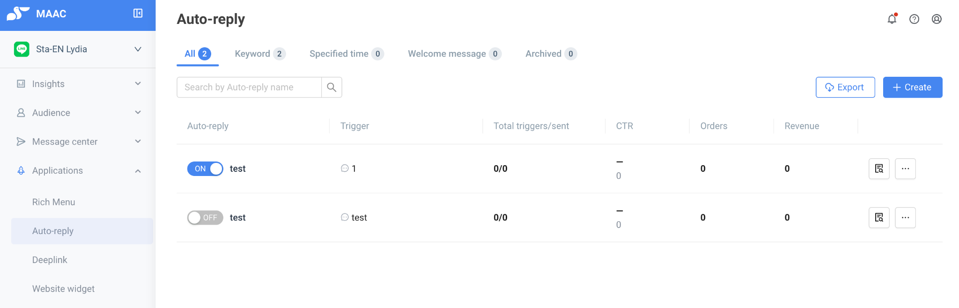
Auto-reply setting:  - Name  - Trigger (Keyword, Time interval, Welcome)  - Tag | 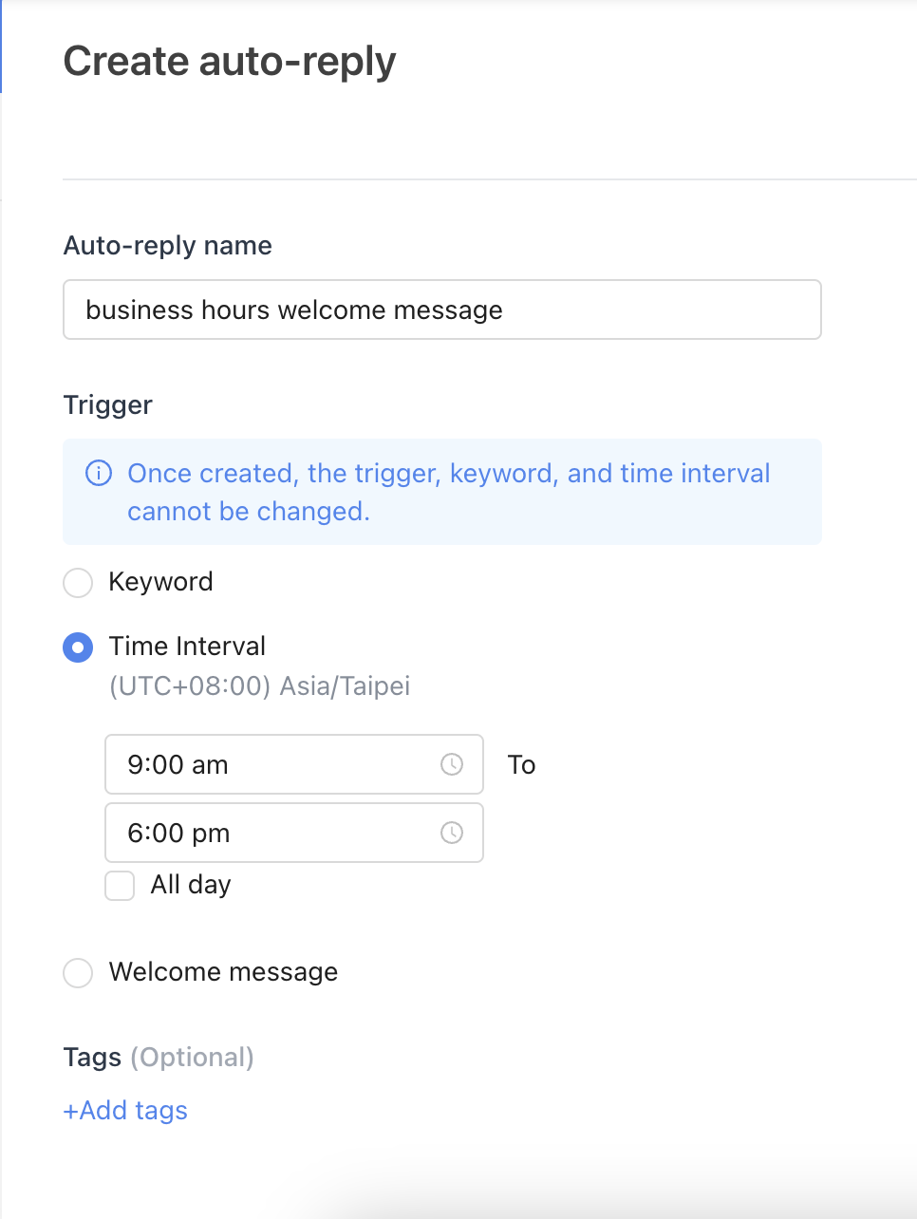
Auto-reply setting:  - Message for unbound/bound contacts | 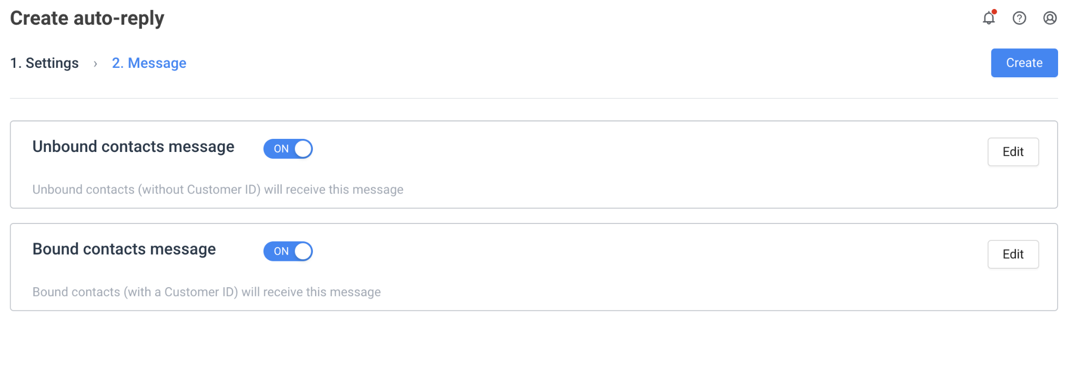

Existing pain points & Biz impact
After we have an overview of existing features, let’s get aware of current users’ pain points:
- Main problems to be solved:
  - Weekly and specific date period setting for specific time auto-reply
    - For sales/service: flexible setting to reply in the non-business hour
    - For marketer: easily to set a auto-reply campaign during holiday
  - Auto-reply trigger times limitation
    - To prevent the repeating auto-reply from bothering consumers when they are entering their questions.
- Business impact:
If we could solve 4 requirements which 27 client mentioned before, this will bring us 716,066 MRR with 439,844 priority(considering brands’ care %)
Detail brands
Requirement ID | Description | # of Brand | MRR | Priority
RC00037 | Auto-reply can set up daily, weekly and specific date period with timespan | 13 | 336,331 | 211,406.6
RC00010 | Multiple keyword triggers one Auto-reply | 11 | 325,351 | 195,033.6
RC00407 | "Auto-reply within specified time interval" can limit how long it takes to trigger once. I hope it won't trigger every time a message comes in. | 2 | 28,159 | 28,159.0
RC00036 | Auto-reply can add scheduling functions | 1 | 26,225 | 5,245.0
總和 |  | 27 | 716,066 | 439,844.2

Auto-reply component level and concept
- Operating schedule:  - Auto-reply auto activate or deactivate time  - Trigger with time interval:  - recurring: daily/weekly/monthly  - specific time period  - Trigger with content rule:  - Welcome message  - Keyword message  - Any content  - Reply limit:  - 1 times in [N] [hours/days] | 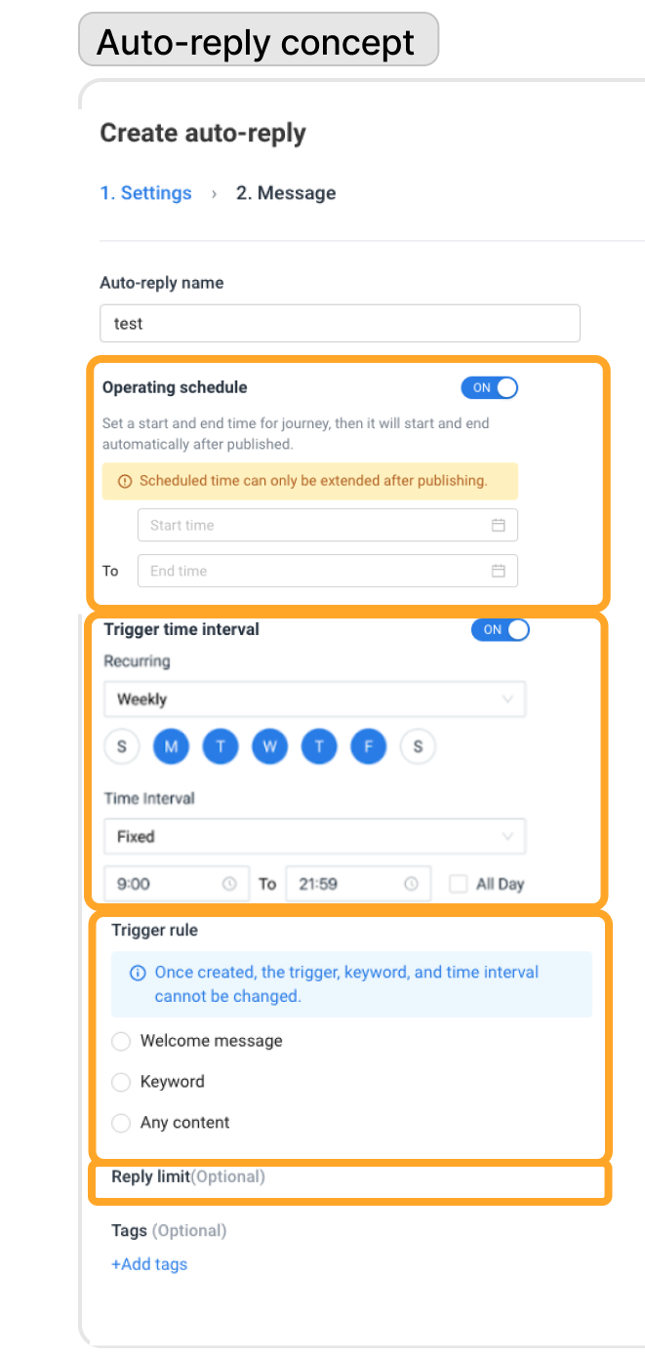

Scope

Within scope
- To solve current pain points, we need to
  - support “time interval with recurring” as an advanced optimization
  - support “reply limit” as a general setting for all kinds of auto-reply trigger
- Here’s 4 features with prioritized:
  - A - Reply type and Scheduling
  - C - Reply limit
  - D - Duplicate
  - F - Reply hours
- Related adjustment:
  - G - List adjustment
  - H - Before and after for existing clients default

Out of scope
- Since auto-reply revamp is not in 2024 and 2025 revamp plan H2 roadmap discussion, so we won’t directly plan details of revamp plan in this PRD, e.g. :
  - auto-reply to support multichannel
  - journey include auto-reply
  - provide category for auto-reply
  - …
- 2024.08.23 after understanding the effort estimation, we decided to refine the scope, and below is not in scope thread
  - A - Trigger with time interval - specific time period
  - B - Trigger with content rule - keywords - 1. Multiple keywords 2. Exact and Partial match
  - E - Operating schedule feature (auto-activate)

User story
- As a store owner, I want to set auto reply by weekday, so I don’t have to manually change the settings weekly when the routing close day is coming
- As a marketer, I want to set auto-reply for holidays or marketing campaigns at one time, so I don’t need to manually change settings after holiday or marketing campaign ends.
- As a marketer, I want to flexibly set multiple keywords for triggering auto-reply, so that I won’t have to set a lot of auto-reply but answer for the same campaign content. (Conditions: Contains any keyword / Contains all keywords / Exact match.)
- As a marketer, I want to pre-build and schedule the auto-reply campaign before the weekend, so that I won’t have to activate the auto-reply during my weekend time.

Metrics & Key Results

- Goal: Improve NDR by solving the high-request requirements
- Success criteria -
  - Adoption: 20% of clients adopt the business hour setting and apply to auto-reply
    - According to 2023/01/17 data: 76 out of 307 (24.76%) time scheduled auto-reply is about offline hours notification. Let’s assume that 50% of them need different settings for weekdays from weekends. That’s about 12%.
    - According to 2024/09/16 meeting: we’ll use business hour setting to solve the user scenario who need to have different auto-reply for week days and weekend. 25% time scheduled auto-reply is about offline hours notification. Let’s assume that 80% of them need different settings for weekdays from weekends. That’s about 20%.
      - Change success metric from 12% WAU of newly added trigger types (recurring) to 20% auto-reply client adopt business hour setting
  - Satisfaction: 80% of clients satisfied with the auto-reply opt.
    - According to 2024/09/19 meeting: we decided to set the Userflow with simple satisfaction form to investigate whether solve user’s pain point, and gain feedbacks as a ingredient for 2025 auto-reply opt.
    - According to 2024/11/18 decision: we decided to ask CS to directly collect feedback from clients, to verify our assumption when building the auto-reply optimization.
- Other metrics - Usage
    - # of auto-reply using welcome/ keyword/ general trigger type
    - # of keyword auto-reply with specific time period
    - # of general auto-reply with daily/ reply hours/ monthly
    - # of auto-reply with reply limit setting
    - # of auto-reply with duplicate function
- Raw data table PM added one, Eng feel free to add this
  - Table - auto-reply setting
    - Org_id
    - auto reply id
    - auto reply name
    - trigger type: welcome/ keyword/ general
      - keyword: with specific time period
      - general: with daily/ reply hours/ monthly
    - reply limit setting
  - Table - auto-reply performance
    - Org_id
    - auto reply id
    - auto reply name
    - TTL triggers: existing contact - unbound / bound
    - TTL msg sent: existing contact - unbound / bound
    - Performance: Clicks, Items add to cart, Orders, Revenue
  - Table - reply hour
    - Org_id
    - reply hour setting
  - Table - trigger record
    - Org_id, bot_id
    - LINE_uid
    - auto reply id
    - auto reply name
    - time stamp

Feature spec

A - Reply type and Scheduling

 | Welcome | Keyword | general reply
Scheduling | X | - No specified date range  - Specified date range | - Monthly  - Based on reply hours/ non-reply hours  - Daily with time-setting
Setting rule | X | cannot set same name keyword, even the auto-reply is deactivated. (as-is) | - Monthly:  - could choose at most 5 dates with same time period  - cannot set the same date of other monthly auto-reply  - Reply hours: will in Business hours setting in Organization setting (Details see F. reply hour)

- Trigger prioritization
    - Trigger rule:
      - Welcome: happen when a new friend join LINE OA
      - keywords > general reply
    - Scheduling:
      - recurring-Monthly > reply hours > recurring-daily
- Scheduling edit rule:
  - once complete create, cannot be edit.
  - Logic: for clear reporting, to decrease confusing if edit the timing. Besides, users could use “Duplicate” for any adjustment

- The time picker details
  - all day as default -> When users choose “all day”, time picker will be set 00:00-23:59 automatically
  - 24-hour time format
  - separate “hour” and “minute” in the menu
  - time period granularity: minute

(X) B - Trigger with content rule - keywords
2024.09.19 moved to the Archived section

C - Reply limit
- To support the “reply limit” feature which allows the user to receive the same auto-reply not exceed a certain of times to prevent bothering users
- Logic:
  - This rule is optional, users could decide whether to turn on this setting
- Solution:
  - 1 times in [N] [hours/days], the upper limit is 999
  - UI ref. beacon Do-not-disturb interval
  - 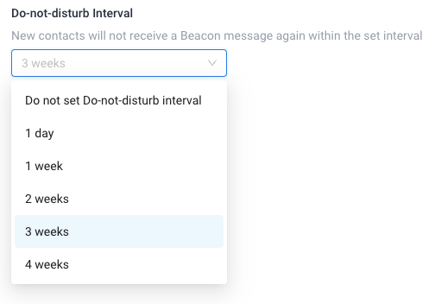

D - Duplicate
Context:
- Currently, after the clients publish auto-reply, then cannot edit the auto-reply trigger rule e.g. edit the keyword, bcs it will affect the performance of report.
- After we support multiple keywords, the inconvenience will be much higher than before. Here’s the discussion thread.
Solution:
- Support “Make a copy” in the auto-reply list
- When the user click on “Make a copy”, then auto duplicate the auto-reply with
  - auto-reply name with “XXXX_copy”
  - keyword with “XXXX_copy”
  - and keep all of other settings

(X) E - Operating schedule feature (auto-activate)
2024.09.19 moved to the Archived section

F - Reply hours
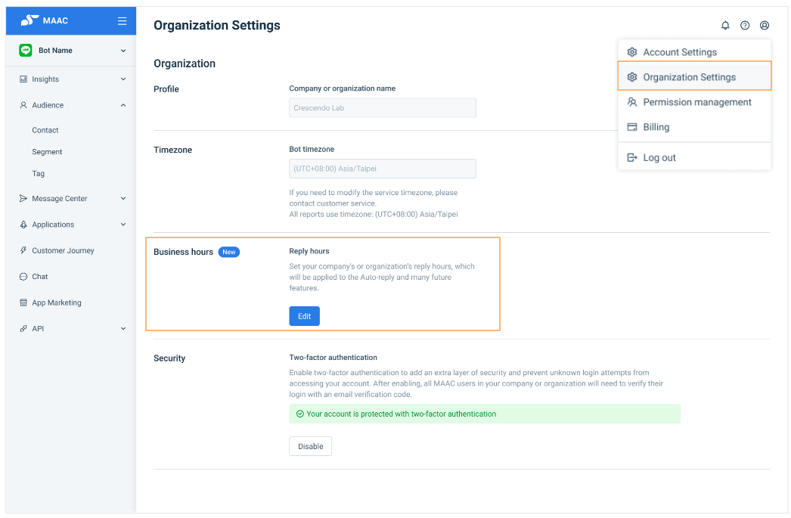
Context:
- According to 2024/09/16 meeting: we’ll use business hour setting to solve the user scenario who need to have different auto-reply for week days and weekend.
- Back to our use cases, over 80% use case is about biz/non-biz hours auto-reply, to make the setting more easily and also solve clients’s main point, we decided to provide reply/ non-reply hours instead of weekly setting in each auto-reply.
Solution:
- Users could go to the organization level setting and see the Business hours section, to set the Reply hours.
- Users could set the reply/ non-reply hours based on their business hours.

G - List adjustment
The adjustment on the auto-reply list
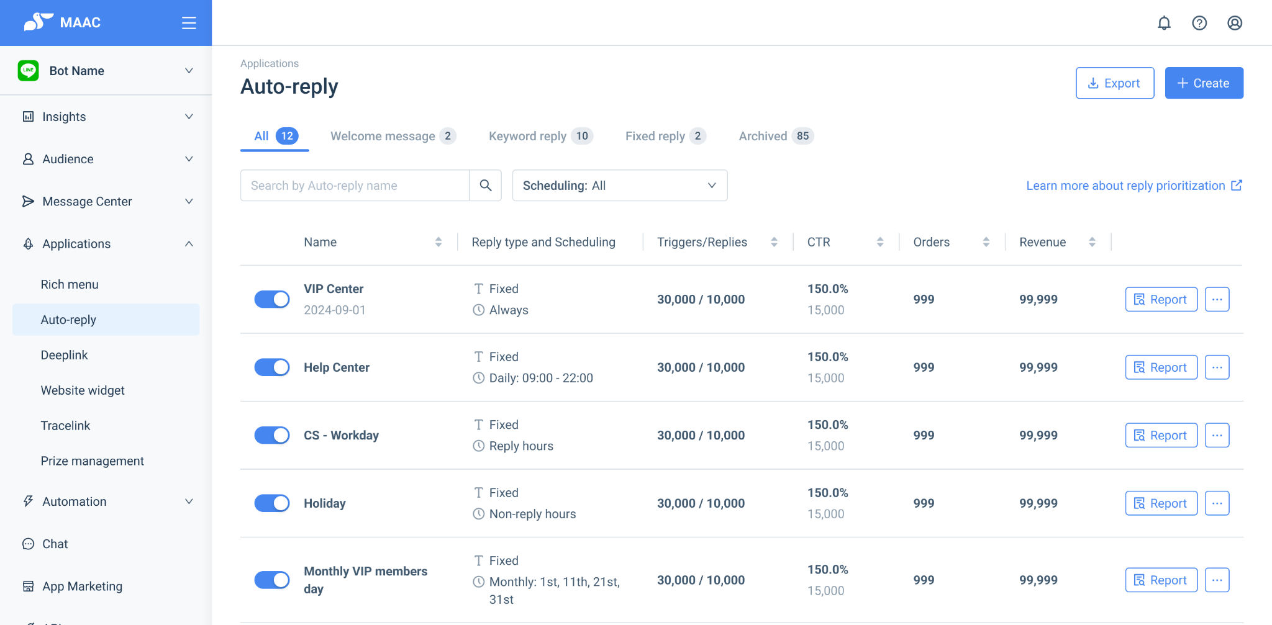
- Adjust column “Trigger” into “Reply type and Scheduling”
  - Reply type:
    - Welcome
    - Keyword
    - general
  - Scheduling:
    - Daily recurring: display the time period, e.g. Daily: hh:mm - hh:mm
    - Reply hours / Non-reply hours
    - Monthly recurring: display the selected month date, e.g. Monthly: 1st, 11th, 21st, 31st
- Adjust tab “Specific time” into “general reply”

H - Before and after for existing clients default
When existing clients turn to new feature, the default value is as the list as below:

New setting | Existing setting - Welcome | Existing setting - Keyword | Existing setting - Time interval
Trigger with time interval | off | off | Time (as setting)
Trigger with content rule | Welcome | Keyword | general reply
reply limit | null | null | null

Dependency

Release plan

Timeline
Milestone
- M1 - reply limit & biz hour 10/1~10/14, by 10/17 complete test and bug fixing for M1
- M2 - auto reply with time 10/17~11/12, by 11/15 complete test and bug fixing for M2
- M3 - duplicate & list 11/18~11/22, by 11/27 complete test and bug fixing for M3

Releasing timeline
- Tier 1 11/27 15:00
- Tier 2 12/4 15:00
- Tier 3 12/11 15:00 → check whether delete this tooltip
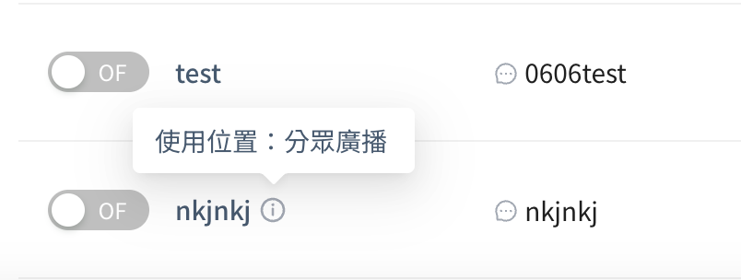
- Tracking data
  - Metabase
  - Survey plan
- Note
  - follow release tier
  - Logic: Since 27 client falls into all service level, so in this project, will directly using service level for tiering, won’t choose specific client list.
  - 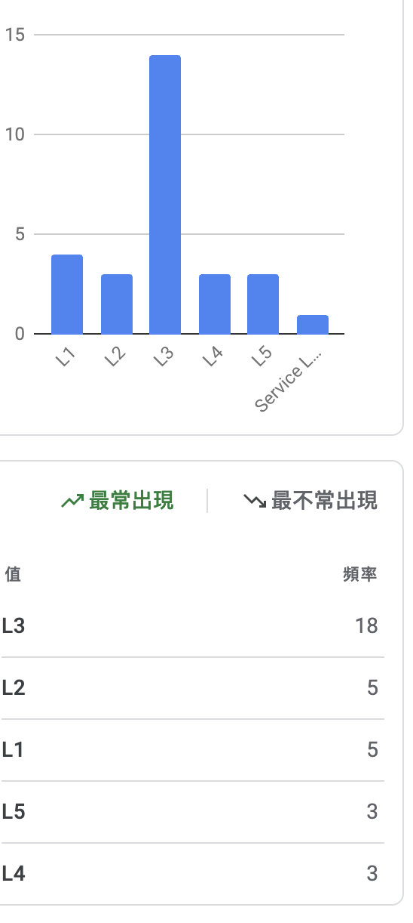

Pricing plan
As-is, no change.

Release region
Please check the gray out feature list (Link)
- TW | - TH | - JP

GTM plan

How do users adopt
- self-serve

How do users troubleshoot
- self-serve

Development Documents

Design docs
- Design
  - Design crit for Switch figma → E1 (need audit log)

QA docs
- Test Case - Auto-reply opt._24.Q4

Post Release

Monitoring
- Daily check the issues within the 1st week (required)

Feedback collection
- Collect the feedback from CSM/GTM within the first 4 weeks (required)

Outcome & learnings sharing
- Collect the metrics results within the first 8 weeks (required)
- Finish the learnings within the first 8 weeks (required)
- Share the outcome at monthly R&D all hands (required)
- Share the outcome at company all hands (optional)
- Share the outcome at QBR (optional)

Next steps
- Finish the next step within the first 8 weeks
  - Case close
  - Iteration

Future plan
- 2025.Q1 Auto-reply will be moved to platform layer to support CAAC
- 2025.H2 Auto-reply will be combined into journey

Discussion and open questions

20241115 General reply 通用回應 名稱定案
固定回應 Fixed reply → 通用回應 General reply
- 回應任何文案都走此通用回應，下一層再看排程的設定
- General 要翻譯成日泰相較也比較準，fix 可能需要語境才能貼合翻譯、default 聽起來只會有一組->不合用
預計放上排序內容的地方及文案，proposal 如下，Johny 可以直接 overwrite：
- 列表 tooltips:
  - 當自動回應是啟用狀態，將會依以下情況回應：
    - 1. 新聯絡人歡迎訊息：當新聯絡人加入 LINE OA 時自動發送。
    - 2. 關鍵字回應：對指定的關鍵字進行回應。
    - 3. 通用回應：對任何發送的聊天內容進行回應。
- 排程 description in setting page:
  - 若多組自動回應排程重疊，回應排序為每月 > 回應/非回應時間 > 每日。
thread

20241112 Reply limit 觸發上限時，不繼續判斷下個 auto-reply
- Problem: 當該 auto-reply 的 reply limit 到達上限時，則該 auto-reply 不進行回應，是否需要繼續往下判斷下一個 auto-reply
- Proposal:
  - 不繼續判斷下個 auto-reply
  - Logic: reply limit 的用意在於限制該 auto-reply 不要過於擾民
thread

20241112 Auto-reply next-day setting only on daily general auto-reply for now
- Context(考量以下):
  - LINE OA manager 原生後台有支援跨日設定
  - CL 既有 auto-reply 也支援跨日設定
- Proposal:
  - 支援跨日設定 → daily 起訖時間都可以是 24 hr 的任一時間
（移除 迄 需要晚於 起 的時間設定）
  - 時間顯示方式
    - <cht> 20:00 ~ 隔日 02:00
    - <ja> 20:00 ~ 翌日 02:00
    - <en> 20:00 to 2:00 am (next day)
    - <th> TBD
- Decision:
  - 現在:
    - 僅於 general auto-reply 的 daily 加上跨日設定（next-day)
    - 假設目前情境以 non-biz hour 的回應為主，因此此階段不考慮 monthly 也要加上跨日設定
  - 未來：
    - 持續觀察是否有收到其他反饋
    - 未來需要加上，可以針對 monthly 去做單一日期多時間區間的判斷（目前無法設定同一天的 monthly auto-reply)
- To-do:
  - Jhenyi Jhan協助撈資料，確認過去有哪些跨日設定 auto reply
  - Johny Hsieh協助確認跨日時間多語系顯示方式

20241108 Auto-reply list tooltip metric tracking → to check whether delete this tooltip
- 背景：FE - Noel 在調整列表，詢問 PD - Johny 這個 Tooltips 會怎麼 layout
- 過程：廣泛詢問 CS (Lanchi, Dash)、FE (Jack, Simon)、BE (JY)、David、Catherine、PM (Lydia) 理解了技術架構中意涵，但是對使用者的實用性沒有定論
- 決議：
  - 目前維持現狀：Tooltips 伴隨在標題右方
  - 新增數據追蹤：由於不確定是否有用戶使用，直接拔掉怕產生痛點，FE Noel Lo 加上 GA Tracking 進行觀察 ticket
  - 追蹤期：現在起 ～ Tier release 階段
  - 最終行動：by 12/11 Tier 3 release，PM Lydia Hou 觀察數據並決定保留或移除

9/10 discussion
Aligned
- Daily, weekly → 營業/非營業時間設定, Monthly

Proposal, target to align
- Time-based 拆成兩層: Monthly > daily, 營業/非營業時間
- 比對不能重複：Monthly time, Daily time, 營業/非營業時間，分開來比對
- 列表排序按照分類排序

Timeline
9/10 Final spec adjustment and kickoff
9/11 Design proposal for recurring settings
9/12 Design discussion for recurring settings
9/13 or 9/16 Final design handoff

9/9 Lydia archieved previous metric setting
- Goal: improve the flexibility and automation of auto reply
- Success criteria: 12% WAU of newly added trigger types (weekly recurring + specific date)
  - According to 2023/01/17 data: 76 out of 307 (24.76%) time scheduled auto reply is about offline hours notification. Let’s assume that 50% of them need different settings for weekdays from weekends. That’s about 12%.
- Adoption/Retention
  - Weekly active usage of daily recurring auto-reply
  - Weekly active usage of weekly recurring auto-reply
  - Weekly active usage of specific date auto-reply
- Raw data table
  - Eng to add this

7/29 Mon. Lydia 先補完今天討論的內容, 也可先讓 Johny 知道 and 找 Peter sync
  - auto reply 數量級 for each client -> category 等問題
  - Q: 手動開關是否仍需要存在
  - Q: time & keyword 是否要復合使用
  - edge case: 思考一下，有沒有東西會影響到過去 auto-reply
  - Migration 舊的 因為舊的時間機制是套用關鍵字
    - 舊的 process 客戶會否很麻煩（新的要夠好用）
  - 多組、時間和關鍵字，展開維度重新統整
  - 順序和排序
- 7/30 Tue. sync with proj. team

- Auto reply (找 Jenny)
  - vs CAAC AI conversation → MAAC then AI conversation
- 加上 problem/value 等
- JP requirement learn from Soji and Yun → 7/16

Previous planning

1. Type | Daily recurring | 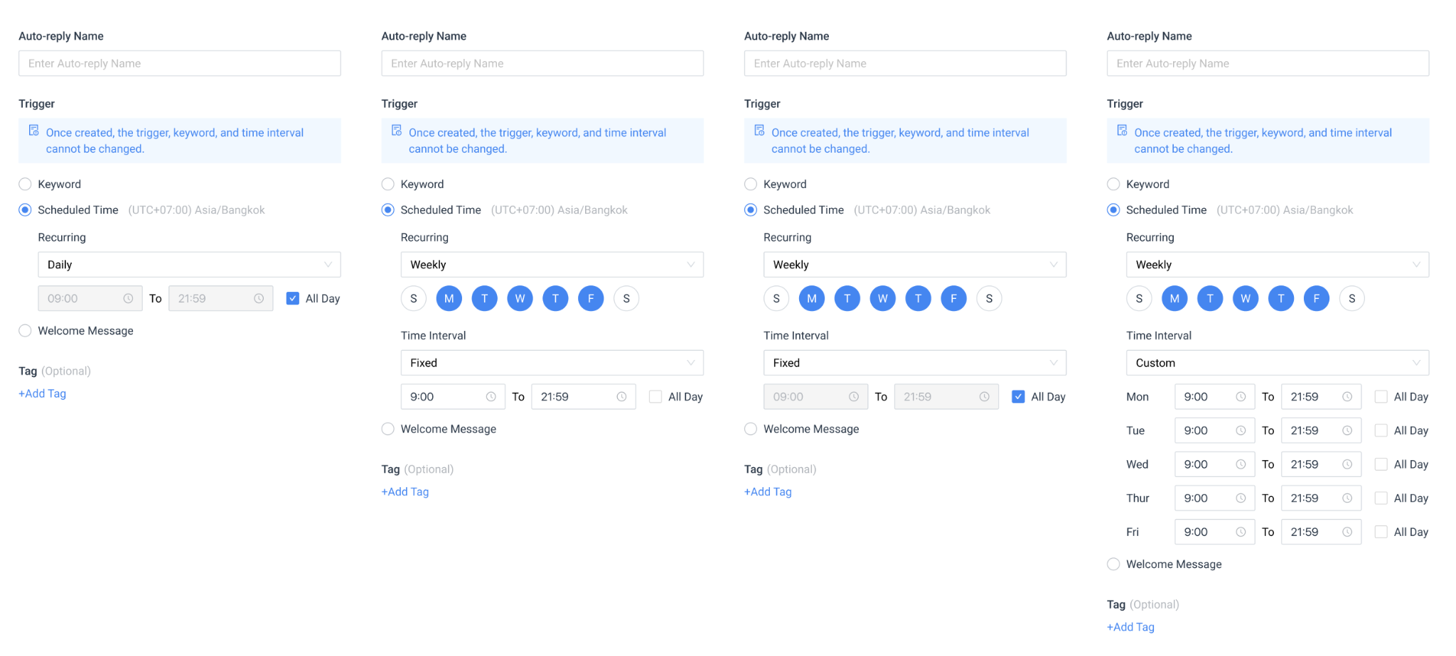
2. Week | (skip)
3. Time interval | (skip)
4. Time period | [start] to [end]  - All day

1. Type | Weekly recurring
2. Week | M,T,W,T,F,S,S (Multiple choice)
3. Time interval | general | Custom
4. Time period | [start] to [end]  - All day | [start] to [end] / Each  - All day / Each

1. Type | specific date | 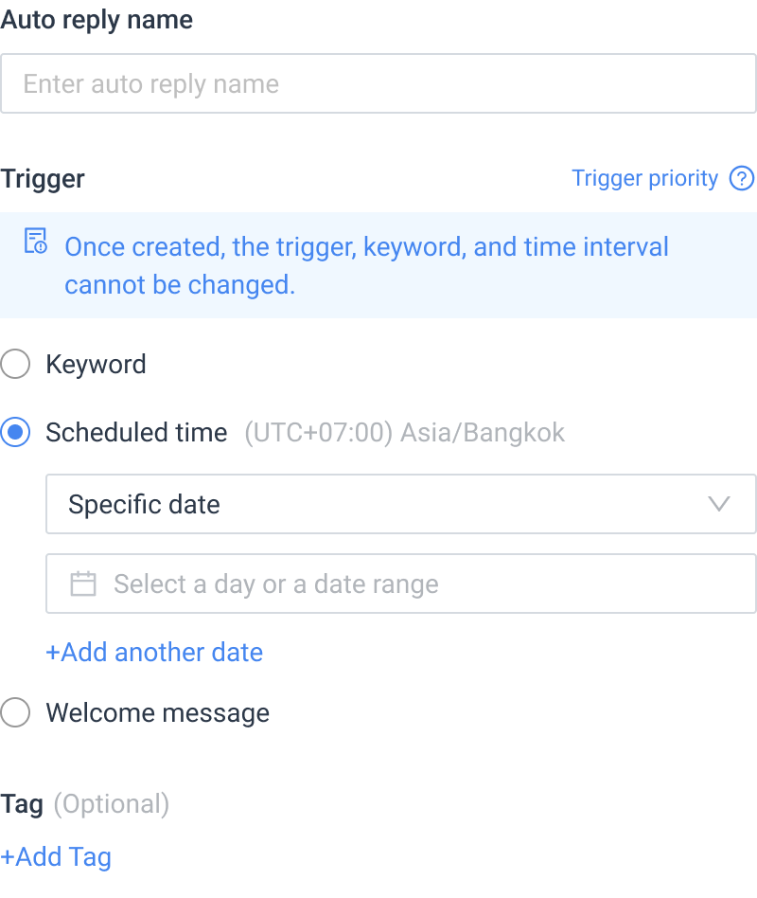
2. Date & time | Select date and time interval
3. Add another date | (Opt.) Add another date setting if needed  Maximum: 30 triggers

Archieve

Archieved
(X) B - Trigger with content rule - keywords - 1. Multiple keywords 2. Exact and Partial match
- Previously: we only provided 1 set of keywords and the Exact Match rule.
- Proposed:
  - Support multiple sets of keywords, the upper limit is 30 sets. Keyword string limitation keep as-is 32 characters (MAAC_Input limitations 輸入規格限制表)
  - Support both Exact Match (完全比對) and Partial Match (部分比對)
    - Partial Match definition: includes keywords, does not include partial characters, case insensitive (包含關鍵字、不包含拆字、不區分大小寫)
  - Keep as-is:
    - cannot set the same keywords in different auto-reply
      - need to check both Exact and Partial Match, all auto-reply status need to be included
    - The pop-up reminder need to show which auto-reply already set the same keyword
  - If the user content include more than 1 keywords in different auto-reply, then Only trigger the latest created auto-reply. (ref. of decision)
- The adjustment on the auto-reply list
  - Auto reply with “keyword” - Trigger column display:
    - Show rule is Exact match or partial match
    - Show the keywords, if the content exceeds the column, then show ”…”
(X) E - Operating schedule feature (auto-activate)
- To support the “schedule” feature which support the user to
  - auto-activate the auto-reply with start [date+time]
  - auto-deactivate it with end [date+time]
- User could choose whether to turn on the operating schedule:
  - If the operating schedule is off: Then this auto-reply won’t be auto-activate nor auto-deactivate
  - If the operating schedule is on: Then the user could set
    - either auto-activate the auto-reply with start [date+time]
    - or auto-deactivate it with end [date+time]
  - Logic of start and end time:
    - start [date+time] & end [date+time] each could be empty.
    - if only fill-in end [date+time]: then activate directly, and end with that time.
    - if only fill-in start [date+time]: then start with that time, and won’t auto end.
    - Scheduled time can only be extended after publishing.
  - Time selector: Same as the Journey Operating schedule
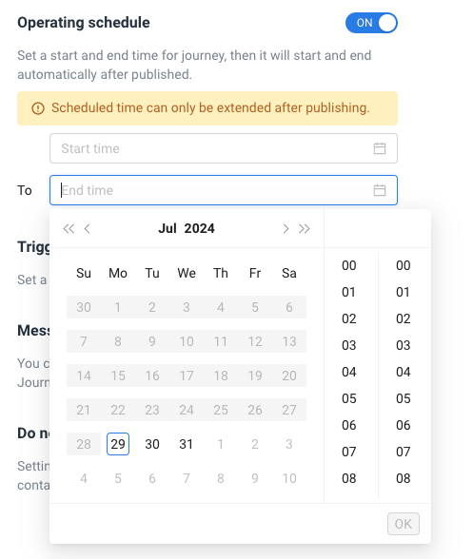
- The adjustment on the auto-reply list
  - Manually activate/deactivate > auto-activate/auto-deactivate
  - If the user manually activate the auto-reply which is before/after the operating time
    - show a pop-up with reminder to check if the user want to reactivate this auto-reply
    - if the user choose to re-activate the auto-reply, then turn off the operating schedule setting and activate the auto-reply
  - Add a column to show the operating schedule which been set
    - Column name: operating schedule
    - Column content:
      - yyyy-MM-dd ~ yyyy-MM-dd
      - if only start time then show: yyyy-MM-dd ~
      - if only end time then show: ~ yyyy-MM-dd
  - 